sec-scor-cbrthrtanalyint-30
Modern Cyber Threat Analysis and Intelligence
Student Guide
Volume number
Version Number
Part Number

Table of Contents

Section 1: Modern Cyber Threat Analysis and Intelligence 1
Threat Actor Taxonomy and Motivations 3
Common Attack Vectors 9
Credential Compromise Impact on Data Breach Risk 17
Cyber Security Intelligence Lifecycle 22
Summary 27
Summary Challenge 28
Answer Key 30

Section 1: Modern Cyber Threat Analysis and Intelligence
Introduction
Users, devices, and applications within your organization are connected across on-premises and cloud platforms in a modern, distributed environment. There are security controls in place: firewalls enforce access control policy, access is restricted, and vulnerabilities are scanned and patched. In theory, the environment appears to be well protected.
Yet incidents persist across the industry, and post-incident analysis shows a consistent pattern. Unknown vulnerabilities or obvious technical bypasses can compromise systems. But most often, access is granted through valid credentials and trusted workflows.
Rather than forcing their way in, modern attackers simply operate within the existing rules. This shift redefines the security challenge. Effective defense now requires a deep understanding of the adversaries, their motivations, and the high-success techniques they favor over traditional software exploits. Isolated events, such as an unusual login or a phishing email, may seem minor on their own, but you must leverage threat intelligence to correlate these signals and uncover the malicious intent hidden within these events.
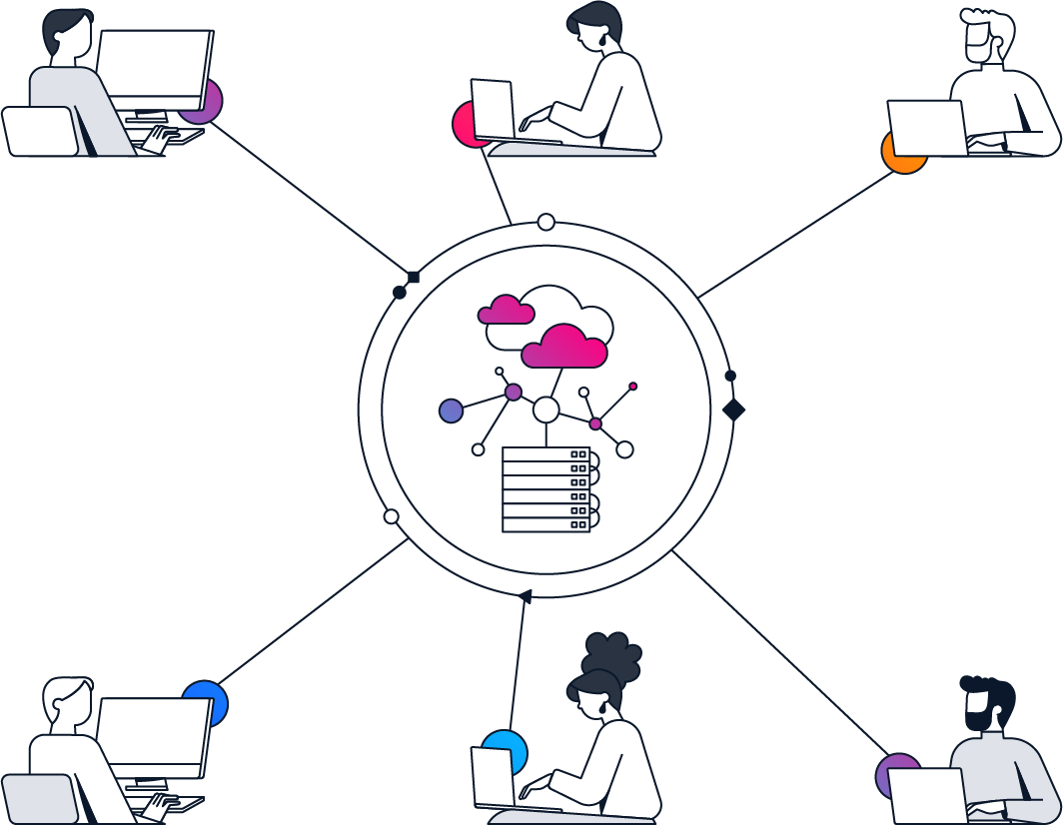
This training enables you to:
- Explain how the motivations and constraints of various threat actors result in predictable attack patterns and specific organizational impacts.
- Explain how various threat actors typically gain initial access using distinct attack vectors across endpoints, identity, networks, and cloud applications.
- Explain how initial access evolves into a complete breach through credential compromise, lateral movement, privilege abuse, and resulting organizational impact.
- Explain how cyber threat intelligence is produced, shared, and consumed to provide ongoing awareness of attacker behavior and emerging risks.

Course to Exam Blueprint Mapping
This course aligns with Cisco 350-701 as outlined below:
- 1.0 Security Concepts
- 1.1 Explain attack threats against on-premises, hybrid, and cloud environments such as viruses, trojans, DoS/DDoS, phishing, rootkits, man-in-the middle, malware, data breaches, insecure APIs, compromised credentials, PQC, and AI
- 1.7 Describe security intelligence authoring, sharing, and consumption

Threat Actor Taxonomy and Motivations
In today’s environment, many attacks blend seamlessly with authorized access and standard business processes. The key distinction between legitimate and malicious activity often lies in the intent. By cultivating threat actor awareness, you can evaluate the same event differently, gaining insight into who is responsible and what they aim to achieve.

Threat actor awareness plays a crucial role in shaping how you respond to security events. Instead of reacting to every anomaly as an undifferentiated threat, you start by asking a more effective question: Who might be behind this, and what are they trying to accomplish?
That mindset gives you a more straightforward way to prioritize response actions even before you have all the evidence.
Optimize your threat assessment by recognizing and avoiding three frequent mistakes: overreacting, oversimplifying, and delaying action.
- Overreacting to a single clue
A single anomalous login or unusual request often stems from benign system changes, user error, or routine operational variations. Treating every minor irregularity as a critical incident drains resources, disrupts business operations, and leads to "alert fatigue," causing teams to later overlook genuine threats. A more effective strategy is to log the event, verify its legitimacy, and enrich it with additional context before escalating.
- Treating every attacker as the same
Attackers differ in their goals and methods; some seek quick profit, others aim for long-term access, and others seek to cause disruption. Assuming all adversaries behave the same way distracts you from the real pattern and the clues that matter most. Your analysis becomes significantly more effective when you look beyond the surface-level event to evaluate the attacker’s underlying goals.
- Waiting for certainty
Early clues seldom offer a complete picture. Waiting for absolute certainty often allows a threat to spread unchecked. Instead, gather a small set of additional data points to quickly confirm or challenge your initial theory, allowing for a faster and more decisive response.

Leveraging threat actor awareness is a systematic, repeatable process: build a hypothesis about intent, look for signals that confirm or weaken it, then adjust your analysis accordingly. Understanding the adversary’s identity and purpose clarifies how and why attacks unfold, helping you interpret early clues with greater confidence and less guesswork.
With that foundation in place, your next step is to understand the main categories of threat actors. Each type usually pursues distinct goals and follows different behavioral patterns.
The following figure shows how a single observed security signal can map to different attacker intents. These may include quick theft, stealthy access, or disruption. Each of these intents is associated with distinct behavioral patterns such as rapid financial gain, hidden persistence, or service sabotage.
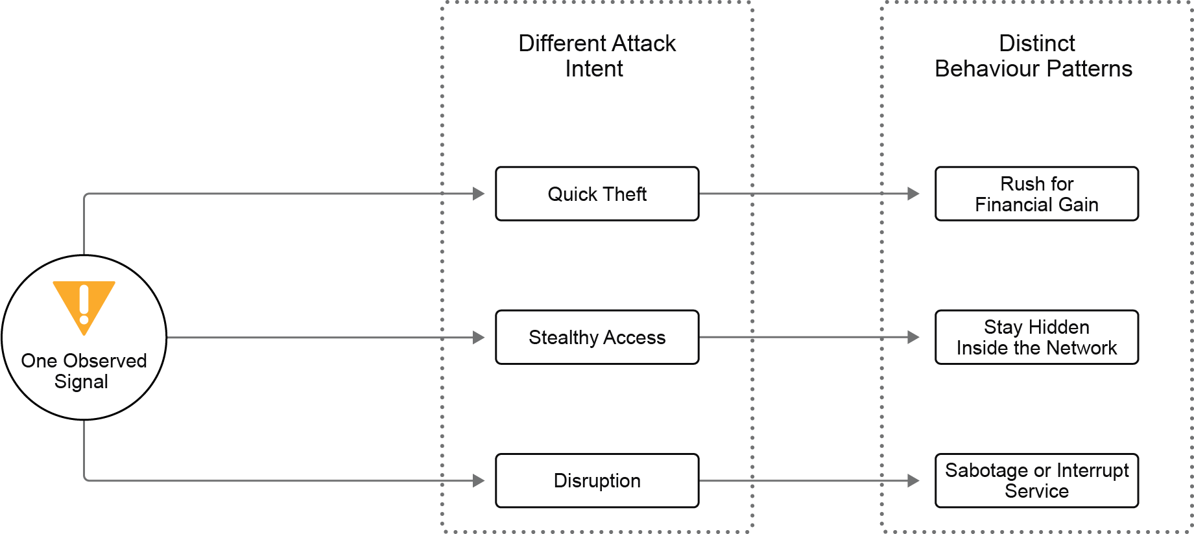
At this stage, your objective is not to pinpoint the exact attacker but to form a working hypothesis. A hypothesis that identifies the most likely intent and predicts what patterns would appear if that assumption held. This approach helps you distinguish between unusual and risky events and prevents wasted effort chasing every odd event as if it carried equal weight.
Before moving ahead, take a moment to recognize the most common ways teams misinterpret early warning signs.
Primary Threat Actor Categories
In today’s environments, attackers rarely break security controls. Instead, they exploit trusted access and legitimate workflows to achieve their goals. This approach makes early signals difficult to interpret, as a single event can represent very different types of threats.
To reduce that uncertainty, start by understanding the main categories of threat actors. Each type usually targets distinct objectives and follows a recognizable operating pattern.
A threat actor is any individual or group that triggers a security incident:
- Imagine a building intrusion: the behavior and impact vary depending on whether the intruder is a thief, a protester, a spy, or an insider with a key.
- The same is true in cybersecurity: understanding who might be behind the action helps you determine their intent and how best to respond.

The following figure shows the four common attacker types, linking each to what motivates them.
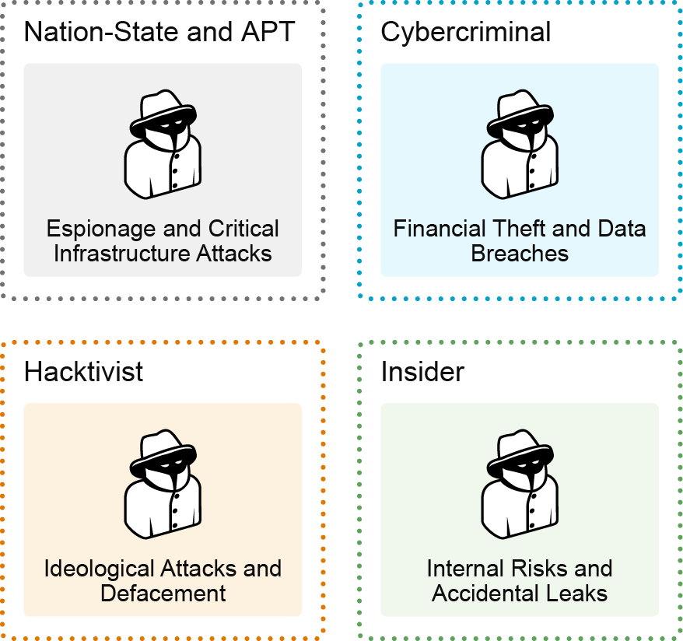
The following are the four common attacker types compared by what they want, how they operate, and success metrics:
- Nation-State Threat Actors
- What they want: Strategic advantage. Their primary objective is to gain access to sensitive data, exert influence, or establish a foothold that aligns with national interests rather than immediate financial gain. They are directly employed, funded, or directed by a government.
- How they operate: They move deliberately and slowly to avoid triggering threshold-based alerts. They may spend months performing reconnaissance before taking a single action. They prioritize Living off the Land (LotL) techniques, using legitimate administrative tools (such as PowerShell or WMI) and valid credentials to make their activity appear routine IT work.
- Success metrics: They maintain quiet and sustained access to high-value systems or confidential information. Indicators of success often include long-term monitoring or data collection rather than open disruption.
- Cybercriminal
- What they want: Financial profit. They target money directly, seek valuable data to sell, or seek leverage to enable extortion or payment.
- How they operate: They focus on repeatable, profit-driven techniques that scale across many organizations. When a tactic loses effectiveness or stops generating income, they pivot quickly to new methods.
- Success metrics: They succeed when they monetize their activity through stolen funds, valuable data, or leverage that forces payment. Speed helps maximize cybercriminal profit, while persistence helps increase control or bargaining power.
- Hacktivist
- What they want: Public attention for a cause. Their goal may include generating awareness, embarrassment, or disruption that supports their ideology.
- How they operate: They prioritize visibility. Their actions often aim to create maximum exposure through public channels, even if that shortens their access time or increases detection risk.
- Success metrics: They measure success through public outcomes such as reputational harm, broad media attention, or visible disruption that amplifies their message.
- Insider (malicious and unintentional)
- What they want:
- Malicious insiders seek personal benefit, revenge, coercion, or an internal advantage.
- Unintentional insiders make mistakes that accidentally expose data or weaken controls without harmful intent.
- How they operate: They begin with legitimate access and knowledge of the environment. Because they use authorized accounts and familiar processes, their activity can look completely normal.
- Success metrics: Indicators include sensitive data exposure, misuse of privileges, or disruptions to operations. The harm may result from deliberate misuse (malicious) or preventable errors (unintentional).

The term script kiddies is commonly used to describe low-skilled threat actors who copy and reuse existing tools rather than developing deep expertise and their own tools. It is included here only as a baseline reminder: Threats range from opportunistic and basic to deliberate and highly capable.

Not all attackers want the same outcome, and they do not operate the same way. Threat actor categories provide a starting map. The focus shifts to what shapes behavior across threat actor categories, how capable a threat actor is, what they must avoid, and how much risk they are willing to take.
An APT is a sophisticated, long-term campaign designed to achieve a specific mission. While most APTs are indeed Nation-State sponsored, any group with enough money, skill, and patience can operate as an APT.

Capabilities, Constraints, and Risk Tolerance
Attackers often succeed by staying inside trusted access and legitimate workflows. This pattern does not happen by chance. It reflects deliberate choices. Attackers select methods based on what they can accomplish, what they must avoid, and what risks they are willing to accept. Understanding these trade-offs helps you recognize attacker logic, especially when their actions appear normal.
The following figure illustrates how capability, constraints, and risk tolerance combine to shape attacker behavior, explaining why some attackers move quietly and patiently while others act fast and visibly in the same environment.
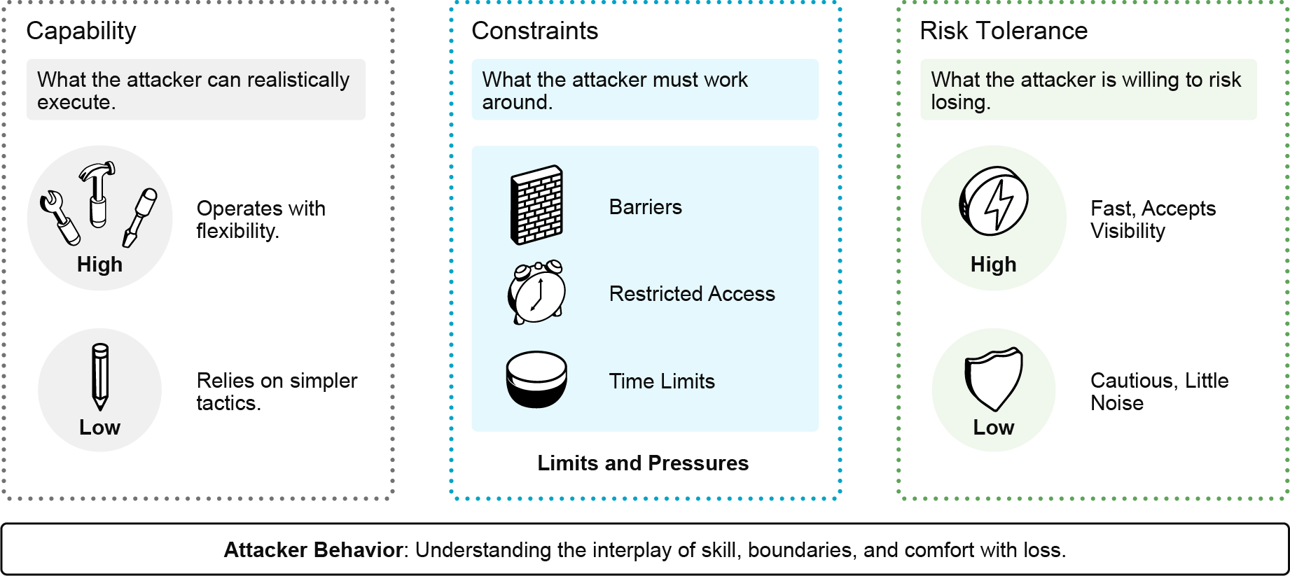
The following list explains how capability, constraints, and risk tolerance interact to shape attacker behavior:
- Capability (What the attacker can realistically execute.)
Capability is what an attacker can reliably do and how well they adapt when conditions change. It is shaped by skill, resources, initial access, and available time. High capability enables flexible, persistent approaches. Low capability tends to rely on simple, repeatable tactics. Any attacker type can be high or low capability.
- Constraints (What the attacker must work around.)
Constraints are the limits that set the boundaries of an attack. Common constraints include restricted access, time pressure, the need to avoid detection, and consequences if exposed. Attackers often choose methods that blend into trusted workflows to reduce friction. Constraints make an attack difficult or expensive.
- Risk Tolerance (What the attacker is willing to risk losing.)
Risk tolerance reflects how comfortable an attacker is with potential losses such as detection, loss of access, escalation, or leaving clear traces. Low risk tolerance produces cautious, low-noise behavior. High-risk tolerance favors speed and accepts visibility to achieve faster outcomes.

Capability establishes the scope of potential actions, constraints define the boundaries of what is operationally viable, and risk tolerance governs the adversary's level of boldness.
Threat Actor Mapping to Real-World Impact
A key shift occurs at this stage. Up to now, the discussion has focused on identifying who might drive certain activities and why they act that way. The perspective now becomes more hands-on: what type of damage is most likely if their efforts succeed?
Treating every incident as a breach oversimplifies reality. Attackers measure their success differently. This means that the ultimate impact can vary significantly, even if the early stages of the attack appear to be business as usual.
The following table connects these two ideas. From abstract analysis to concrete evaluation. Who is behind the activity, and what damage may it cause if this continues?
Impact Category | Business Consequence
Financial | Fines, ransom, and the cost of recovery
Operational | Downtime, productivity loss, and data corruption
Reputational | Customer churn and loss of brand value
Legal | Lawsuits and regulatory penalties
Strategic | Loss of trade secrets and competitive edge

Attacker success follows predictable patterns. The resulting impact typically manifests in several recognizable forms that directly affect the business operations and revenues.
- Operational Impact: Critical business services become unavailable or degraded, halting operations and impacting the customer experience. This creates immediate operational urgency as the organization works to restore normal function.
- Financial Impact: Loss of revenue, ransomware payments, and regulatory fines.
- Reputational and Trust Impact: A company’s reputation drops significantly following a high-profile data breach as investors and customers lose confidence in the company’s ability to safeguard its assets.
- Strategic Impact: A Nation-State actor steals your R&D, blueprints, or "secret sauce" (espionage), a competitor could offer a similar product faster and cheaper.
- Long-Term "Hidden" Costs: Cyber insurance rates skyrocket after a claim. The organization may be forced to undergo expensive, frequent security audits by regulators or partners to prove it is safe to work with again.

Once you have a grasp of the various types of threat actors, the subsequent step is to comprehend the common methods attackers use to gain initial entry into an environment.
1. A group targets an organization and quickly makes the incident public. The messaging is framed around a social cause, and the goal appears to be embarrassment and pressure rather than long-term access or profit. Which threat actor category best fits this behavior?
A. nation-state or APT
B. cybercriminal
C. hacktivist
D. insider (malicious or unintentional)
2. How can threat actor awareness best help the security team prioritize its response when trying to interpret an unusual administrative action: a privileged account created several new access tokens late at night, but no apparent damage has appeared yet.
A. confirming the software vulnerability that enabled the action
B. identifying the exact malware family involved in the event
C. forming a hypothesis about the action and the threat actor's goals
D. guaranteeing that the event is benign if only one account is involved

Common Attack Vectors
A contractor joins a project and expects access to shared documents. The contractor receives what appears to be an email from the IT department indicating that access is ready, along with a link to sign in. Trusting the email, the user clicks the link and enters their credentials on the fake site. The attacker captures the user’s password. Sometime later, the same contractor account begins accessing shared resources outside the project’s scope. These actions succeed because the account carries broader permissions than intended. This activity uses a trusted identity through normal application workflows, making detection more difficult.

Clear and accurate terminology is crucial in incident investigations. Often, terms like attack surface, attack vector, vulnerability, exploit, and technique are used interchangeably, which can obscure the understanding of an attack.
- Attack Surface
The attack surface is the total sum of all possible points (the "exposure area") where an unauthorized user can try to enter or extract data from an environment.
Examples: Open ports, public-facing websites, APIs, unpatched software, and even employees (social engineering targets).
- Attack Vector
An attack vector is the path that an attacker uses to reach a target and initiate an attack. It identifies where the entry occurred in an incident.
Referring to the previous scenario, the email and sign-in link form the entry path that initiates the attack sequence. This path draws the user into a workflow that the attacker can exploit to gain further access.
- Vulnerability
A vulnerability is a weakness that an attacker can exploit, whether technical or human. It explains what enabled the entry route.
- The contractor account holds more permissions than necessary.
- The trusted workflow can be misused to perform unauthorized actions.
- Exploit
An exploit occurs when an attacker uses a weakness to achieve a specific outcome, such as gaining access or performing unauthorized actions. It explains how the weakness turns into a real impact.
In the previous scenario, the weakness becomes an active outcome when the attacker uses the contractor’s identity to perform actions beyond the intended project scope.
- Technique
A technique is the method that an attacker uses to carry out a specific step in their path. It explains, at a high level, how the step was executed.
In the previous scenario, the attacker operates through a trusted identity and within normal application workflows. They perform actions that the environment accepts as legitimate.

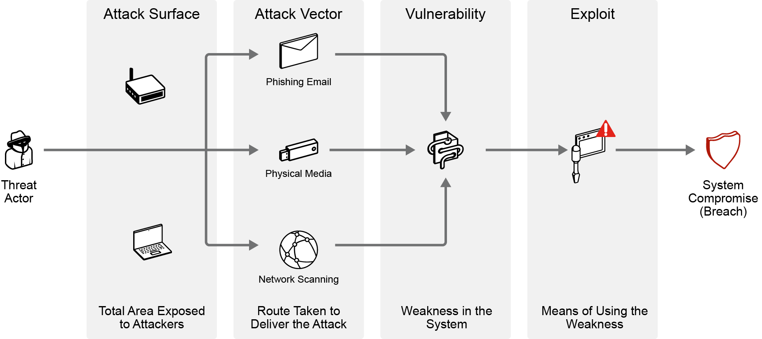
Social Engineering and Credential-Based Attack Vectors
Social engineering and credential-based attack vectors target the "human element" of security. Social engineering involves psychologically manipulating users into performing actions, such as clicking a link, revealing a password, or approving a login request, by exploiting trust or urgency. Credential-based vectors then use these stolen or coerced login details to gain "legitimate" access to a system. Because the attacker is using a real username and password, their presence often goes undetected by traditional security tools, as the system treats it as a valid user logging in through a trusted workflow.
If you receive the email in the following figure, will you trust it and click on the link? What do you think will happen if you click on the link?
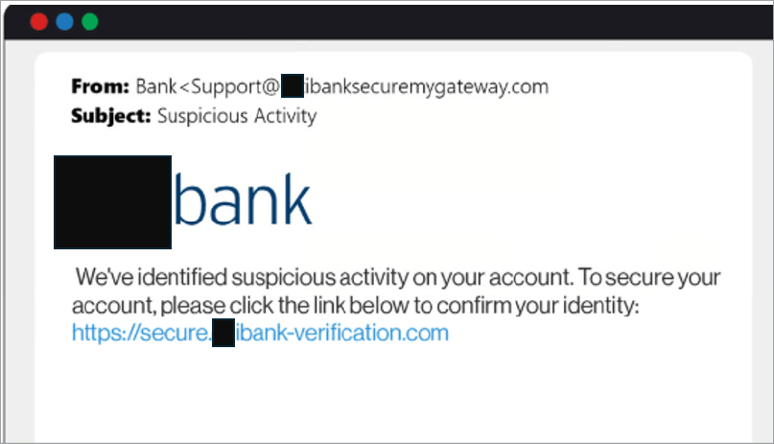
The following figure illustrates the psychological drivers used to manipulate users into making decisions that compromise security.
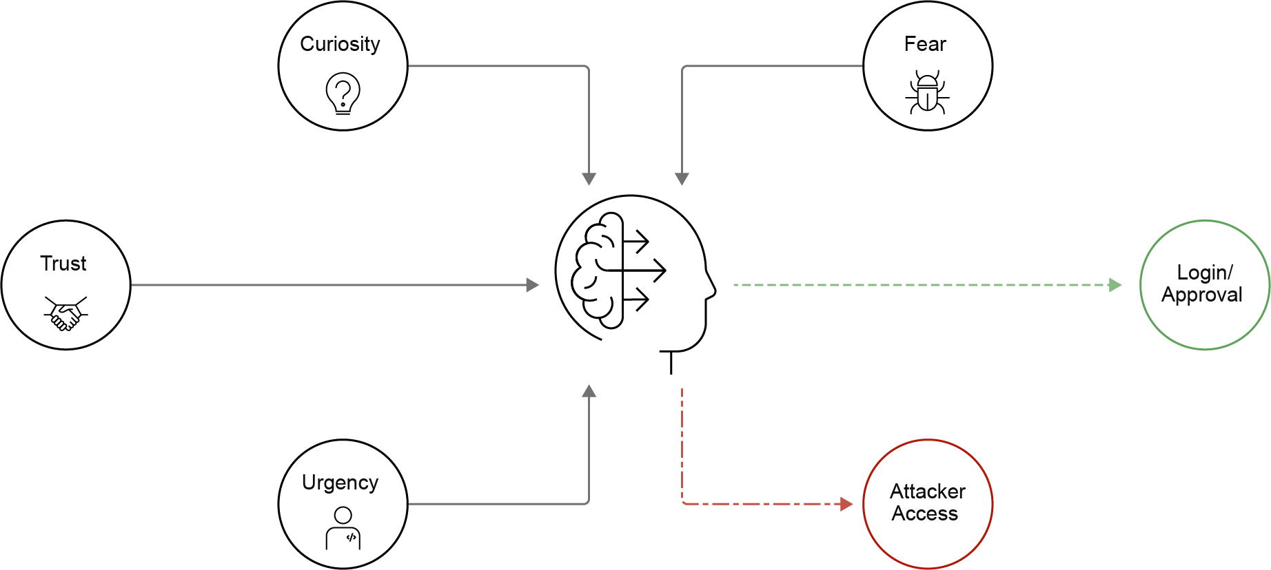
The following are common social engineering attacks:
- Phishing
A deceptive email or message guides the victim to perform a familiar action, such as signing in, verifying an account, or opening a document. The goal is to capture the user’s credentials or approval within a controlled, malicious process.
Entry moment: The attacker gains access the moment that the victim enters credentials or approves the request within a fake or attacker-managed interface.
- Spear phishing
A crafted message appears credible by referencing real roles, projects, suppliers, or organizational details. The attacker personalizes the content to lower suspicion while pursuing the same goal as standard phishing.
Entry moment: The attacker gains access when the victim enters credentials or grants authorization, believing the request is genuine and relevant.
- Vishing
The attacker uses a phone call to apply urgency and authority, pushing the victim to share information or complete a sign-in or verification step while under real-time pressure.
Entry moment: The attacker gains access when the victim discloses credentials or completes a sign-in or approval action during the phone call.
- Smishing
A short message creates urgency and encourages quick action, leading the victim to click a link or comply without careful review. These messages often focus on mobile users, where fast responses are common.
Entry moment: The attacker gains access when the victim enters credentials on a fraudulent sign-in page or approves a request through a rushed confirmation.

Across all social engineering scenarios, the delivery method may differ, but the outcome remains the same. Attackers exploit trusted workflows to capture credentials or authorization, gaining entry by logging in through legitimate channels.
Malware-Based Attack Vectors
Attackers do not always have to steal the user credentials to get in. Instead, they get in because malicious software was executed on the user’s machine.
Malware (malicious software) refers to any software intentionally designed to produce an unauthorized outcome, such as enabling access, stealing data, or granting further control. A malware-based attack vector is the path through which that malicious software is delivered and executed. The delivery channel might be an email message, a website, a shared drive, or an application store. The channel is used to deliver the package, but the actual entry point occurs when the malicious package is executed on the end user’s machine.
The following figure illustrates malware execution within the attack lifecycle, highlighting why it is the decisive moment for gaining initial access.
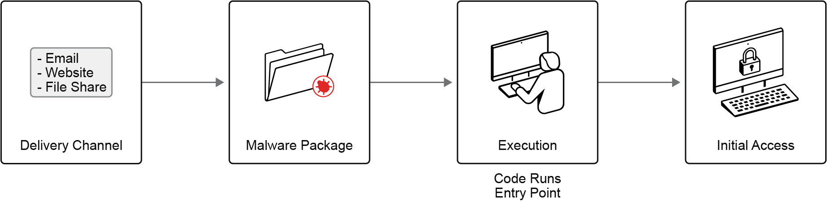
The following are common types of malware:
- Trojan
A Trojan is malicious software that appears to be legitimate or expected.
Example: A contractor receives a link to download a “required document viewer” needed to open a shared file. The installer runs normally, and the viewer seems to install correctly. Behind the scenes, however, additional code executes.
- Virus
A virus is malicious code that attaches itself to another file or program and runs when that host file is executed.
Example: A shared spreadsheet template used across teams gets modified with a malicious macro and redistributed. When a team member opens the spreadsheet, the embedded malicious macro runs during normal file handling.
- Worm
A worm is malware that automatically spreads to other reachable systems after it first runs. Its entry pattern involves initial execution followed by self-propagation.
Example: A user opens a malicious email attachment on one workstation. Soon after, similar activity appears across multiple systems as the malware spreads through available network connections.

Ransomware is not a way into a system (an attack vector); rather, it is the malicious payload that occurs after an attacker has already gained access. Ransomware is a type of malware designed to extort money from victims by blocking access to their own data or threatening to release sensitive information publicly. The attacker "holds the data hostage" and demands a ransom, usually in cryptocurrency, in exchange for a decryption key or a promise not to leak the data.

In most cases, malware-based attack vectors follow a few consistent delivery patterns.
- Run it: A user explicitly runs a file, an attachment, a macro-enabled document, or an installer.
Reflection question: Think about your typical workday. What are examples of "urgent" or "routine" emails that might trick a busy employee into clicking an executable attachment without a second thought?
- Install it: A user installs software, a plug-in, a browser extension, or a mobile application that contains hidden malicious components.
Reflection question: If you found a browser extension that promises to automate a tedious work task, what specific steps would you take to ensure that it meets company security standards before adding it?
- Indirect execution: Opening a document, viewing embedded media, or visiting a compromised web page triggers the malware without the user ever selecting the run or install buttons.
Reflection question: We often treat "opening" a file as a safe, neutral act. How does knowing that a file can execute malicious code just by being viewed change your approach to handling documents from external sources?

These patterns succeed because they blend effortlessly into everyday workflows. Everything appears routine until the moment of execution; that’s the actual turning point.
Malware-based attack vectors require code execution via user action. However, other attack vectors target user behavior and authentication workflows to gain initial entry.
Network-Based Attack Vectors
Some entry paths succeed without convincing a user or executing a file. This category operates beneath the users and endpoints. This attack vector targets the network infrastructure behavior and its underlying protocols, such as shared services and routing protocols. When these vectors succeed, the result extends far beyond a single user. It can take down entire services or break the security of every system on the network simultaneously.
The following figure highlights the two main families of network-based attack vectors and the types of failures that they can cause.
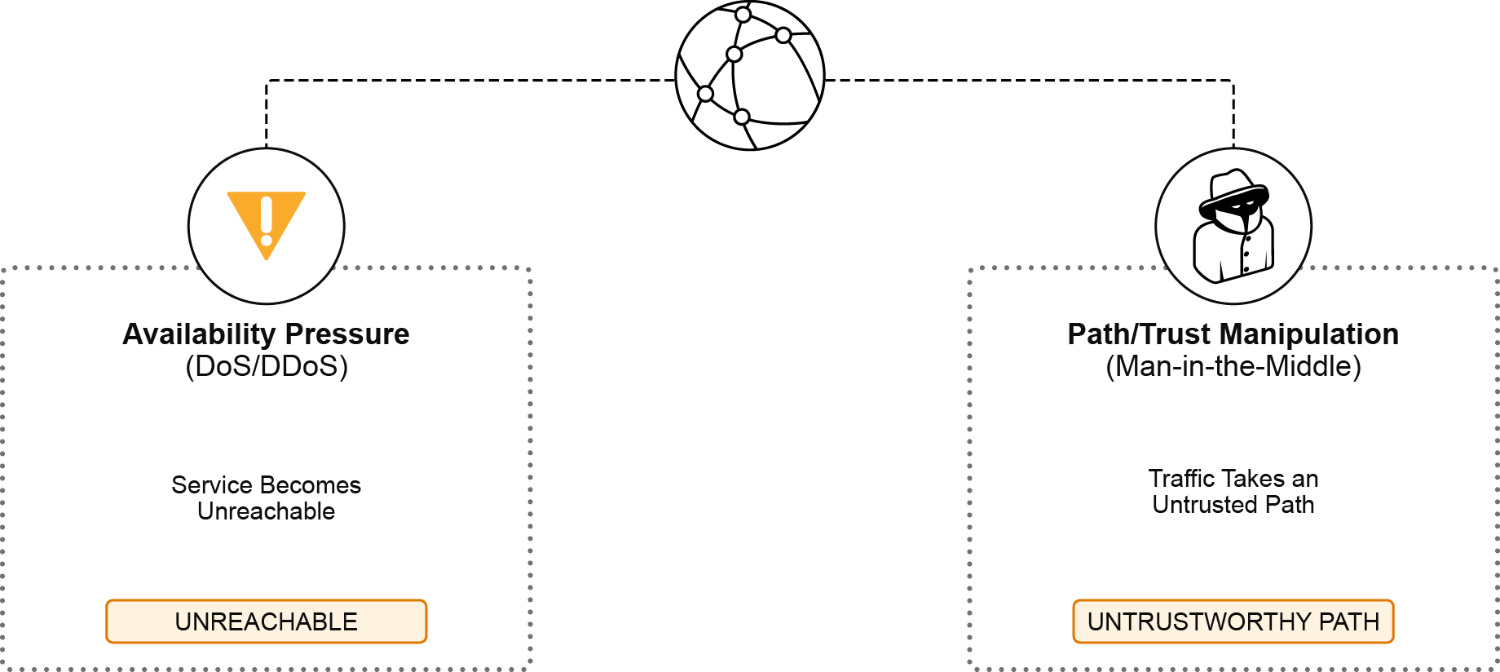
Explore what each attack vector aims to impact:
- Availability Pressure (denial of service [DoS] and distributed denial of service [DDoS])
This vector floods the network services (such as DNS or DHCP servers) with excessive requests, preventing legitimate requests from being processed. Attackers can also flood the network with excessive network traffic.
You might notice symptoms such as widespread timeouts, delayed responses, or intermittent network service availability
When this vector succeeds, the organization loses network service availability. Users cannot access key services, transactions fail, and operations slow down even though systems remain intact.
- Path and Trust Manipulation (man-in-the-middle)
This vector alters traffic flow so that all traffic is transmitted through or diverted to the attacker’s device.
Users and endpoints continue to operate as usual, showing no signs of compromise.
When this vector succeeds, a man-in-the-middle attacker can monitor, modify, or redirect traffic while everything still appears normal to the users.

The next focus area shifts from network-based vectors to overexposed or misconfigured APIs and Cloud Applications.
API and Cloud Applications Attack Vectors
APIs (Application Programming Interfaces) are widely used to enable applications to communicate and share data. Because APIs are often exposed to external users or systems, they can become a common target for attackers. If APIs are not properly secured, attackers may attempt to gain unauthorized access to data, manipulate application functionality, or disrupt services.
The nature of cloud environments introduces unique attack vectors that focus on how cloud applications are configured, managed, and accessed. If the cloud applications are accessible over the internet and integrate with various external systems, misconfigurations or improper management can lead to unintended exposure. Attackers may exploit weaknesses in access controls, insecure user interfaces, or overly permissive settings to gain unauthorized access, manipulate assets, or disrupt operations.
The following figure shows how cloud entry often arises from design and configuration choices rather than explicit compromise.
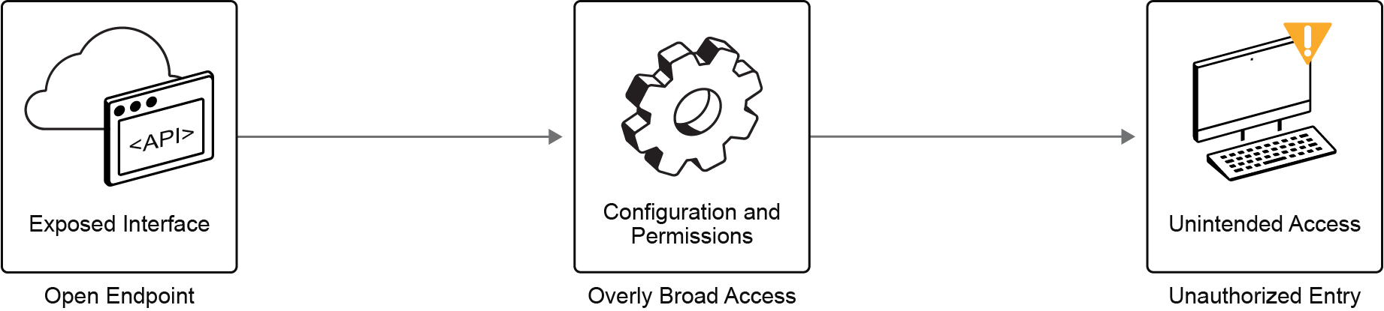
Entry becomes possible when any of the following conditions exist:
- An API that accepts requests it should reject.
- A role or policy grants broader access than intended.
- A resource assumed to be internal is publicly reachable.
- A service trusts another component more than it should.

The following table contrasts two primary entry themes, showing where the weaknesses lie and what success looks like from the attacker’s perspective.
Entry Theme | What does success look like for the attacker?
Insecure API | Gain access to data or functions that should be restricted, take over user accounts, DoS the application, or leverage the access to pivot to other systems.
Misconfigurations | Access is granted because the configuration allows it, even though that access was not intended.

Across both themes, entry often occurs without malware, user deception, or protocol abuse. The entry interface is reachable, the current permissions and configuration allow the request, and access is granted. The entry shifts to “being accepted by an exposed interface and its authorization decisions.” The outcome is: entry moves from breaking in to being allowed in.
From this point, the focus shifts from where entry occurs to what follows successful entry, especially when attackers use valid credentials and trusted workflows.
1. Which social engineering entry category best describes the following scenario? A finance manager receives an email that appears to come from a long-term supplier. The message refers to a recent invoice and requests that future payments be sent to a new bank account. It includes accurate details about current projects. After reviewing the message, the manager updates the payment details as requested.
A. phishing
B. smishing
C. spear phishing
D. pretexting
2. Which statement best distinguishes an attack vector from a vulnerability in the context of an incident?
A. The attack vector is a security patch, while a vulnerability is a log entry.
B. The attack vector is the path in and a vulnerability is the weakness that enables it.
C. The attack vector is the operating system version, while a vulnerability is the user’s role.
D. The attack vector is any malware file, while a vulnerability is any network port.

Credential Compromise Impact on Data Breach Risk
Security incidents rarely start with anything that looks like a break-in. They more often begin with an activity that the environment already expects and trusts, such as an authenticated session, a valid API request, or an approved administrative action.

The challenge is that this first foothold can stay small and quiet yet still become serious if it continues long enough to expand its scope and produce unauthorized outcomes, such as data access, configuration changes, or service disruptions.
Cyber Breach Progression
The following figure outlines a three-step path from initial access to breach, with time and persistence amplifying at each stage.
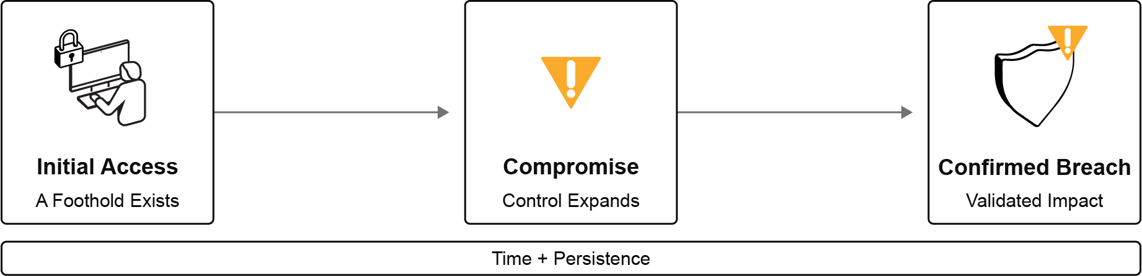
The following list shows the conditions and how they change as the attacker progresses.
- Initial access
- Initial access means that an attacker can interact with the environment in a meaningful way within a single-entry context, such as a single identity session, application session, or workload context.
- A foothold is established when an attacker secures a stable, persistent presence within the compromised environment after initial access.
- Scope usually stays limited to what that identity or service already has permission to do.
- This situation can still be serious, but it does not automatically qualify as a breach.
- System compromise
- Compromise begins when the attacker uses the foothold to gain capabilities beyond the original entry context. This phase often includes expanded permissions or extended reach to additional systems or services. At this point, the environment is not just accessed; the attacker operates inside it with broader control.
- Confirmed breach
- A breach exists when the organization can confirm unauthorized outcomes. Typical impacts include loss of confidentiality (sensitive data accessed or removed), loss of integrity (unauthorized changes), or loss of availability (service disruption). This is the stage at which the attacker's presence becomes measurable harm.

Time acts as a multiplier across all stages. The longer access continues, the more likely it will grow into broader control and then into confirmed impact. Initial access provides the foothold. Compromise represents expanded control. A breach reflects validated organizational impact, and progression usually takes time.
With this progression in mind, the focus now shifts to compromised credentials, which often provide the fastest path to gain initial access.
Credential Compromise Impact
A foothold does not automatically mean a full-scale breach; it becomes one when attackers can expand their access. Once attackers obtain valid credentials, such as user passwords, session tokens, API keys, or service account secrets, they no longer need to exploit technical vulnerabilities. Instead, they can use those credentials to do anything the legitimate identity is authorized to do. In identity-centric environments, where authentication is integrated across applications, cloud services, automation tools, and administrative workflows, compromising a single identity can allow attackers to move freely across systems that would otherwise require multiple separate attacks.
The following figure illustrates how a single trusted identity can span multiple systems.
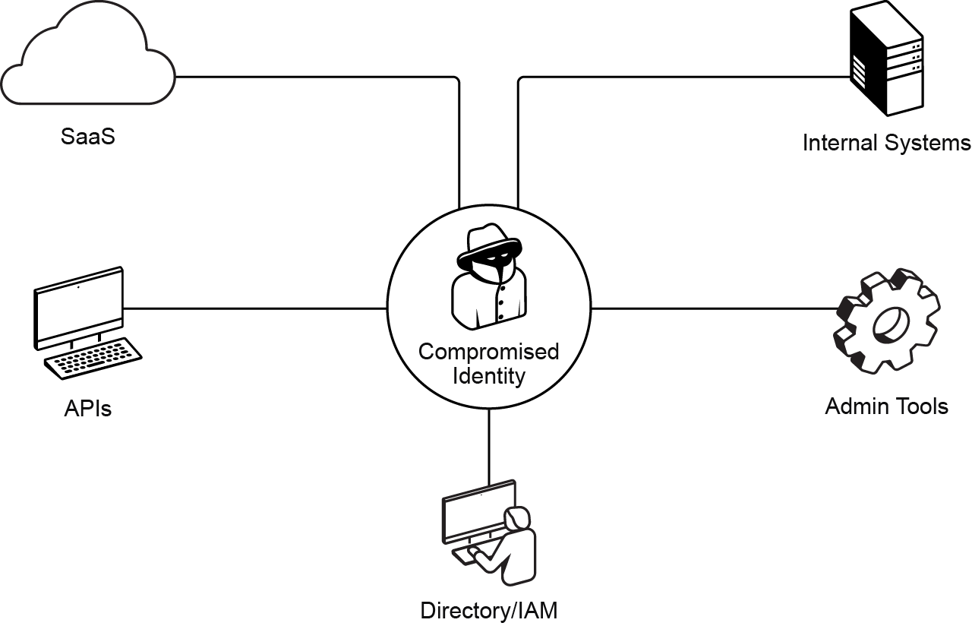
Each component in the diagram represents an established trust relationship with an identity. If an attacker compromises that identity, these trusted connections no longer act as barriers; instead, they become pathways for the attacker to further expand their presence.
Lateral Movement and Privilege Abuse
After initial access, the key question becomes: Which trusted paths exist from this point, including administrative channels, service dependencies, shared credentials, and how far do they extend?
In the lifecycle of a cyberattack, lateral movement, privilege abuse, and privilege escalation are the critical phases that transform a minor security incident into a major data breach. While the initial entry (like a phishing email) gets an attacker through the door, these phases allow them to navigate the building and unlock the vault.

Lateral movement and privilege abuse are often interconnected tactics used by attackers after gaining initial access to a system, as shown in the following figure.
- Lateral movement is how an attacker pivots between compromised systems and accounts to reach critical servers and sensitive data. Most defenses still focus on the perimeter, so internal networks often allow relatively free movement once an attacker is inside.
- Privilege abuse is the misuse of legitimate access rights to read sensitive data, change configurations, or quietly maintain persistence.
- Privilege escalation is the process of turning limited access into high-level control by exploiting weak links and misconfigurations (for example, writable config files or credential-dumping tools like Mimikatz). It is usually multi-step and combines technical flaws with configuration mistakes or social engineering.

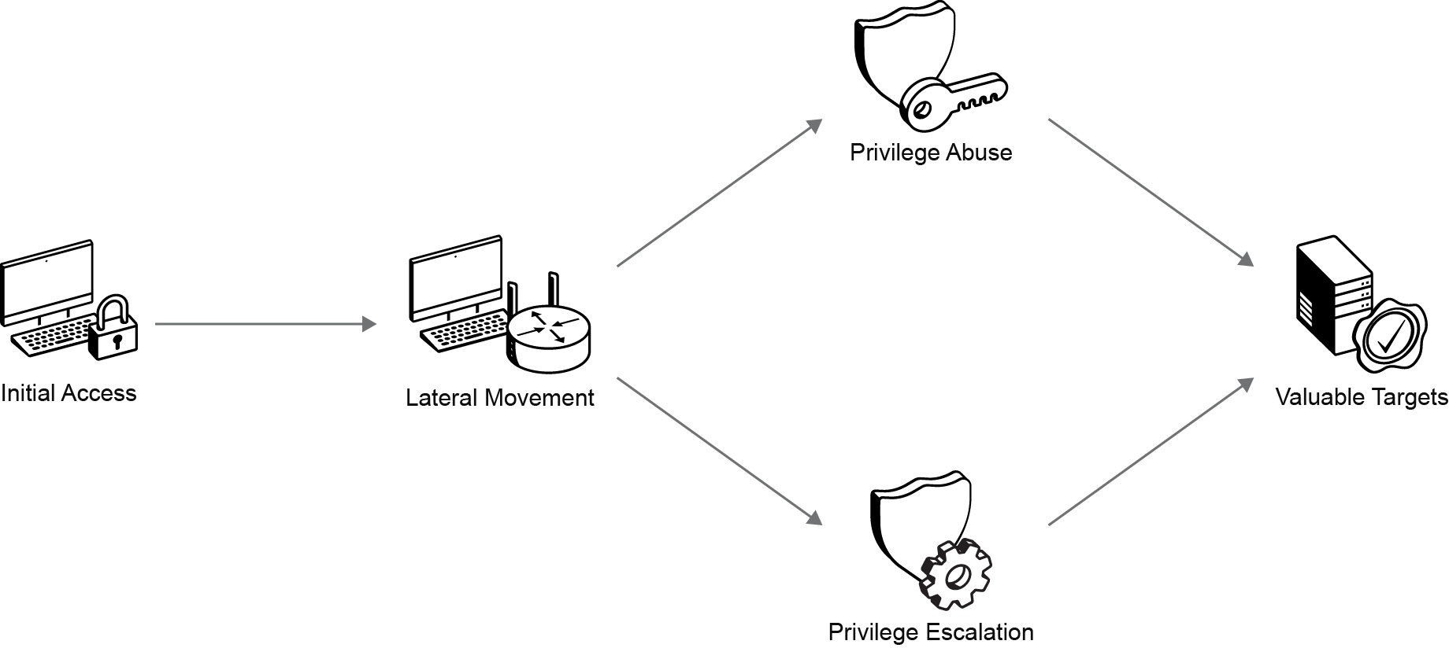
As the attacker’s access grows, the core question shifts from how they move to what this expanded reach ultimately costs the organization.
Data Breaches Organizational Impact
Think of initial access like a burglar breaking into a house through a window. If the rest of the house is wide open, they can take everything. But if every internal door is locked and the valuables are in a bolted-down safe, the break-in is a nuisance rather than a catastrophe. Entry is just the start; your internal security determines if they leave with the 'crown jewels' or empty-handed.

The following figure summarizes the idea: initial access is only the starting point while internal controls determine the final impact.
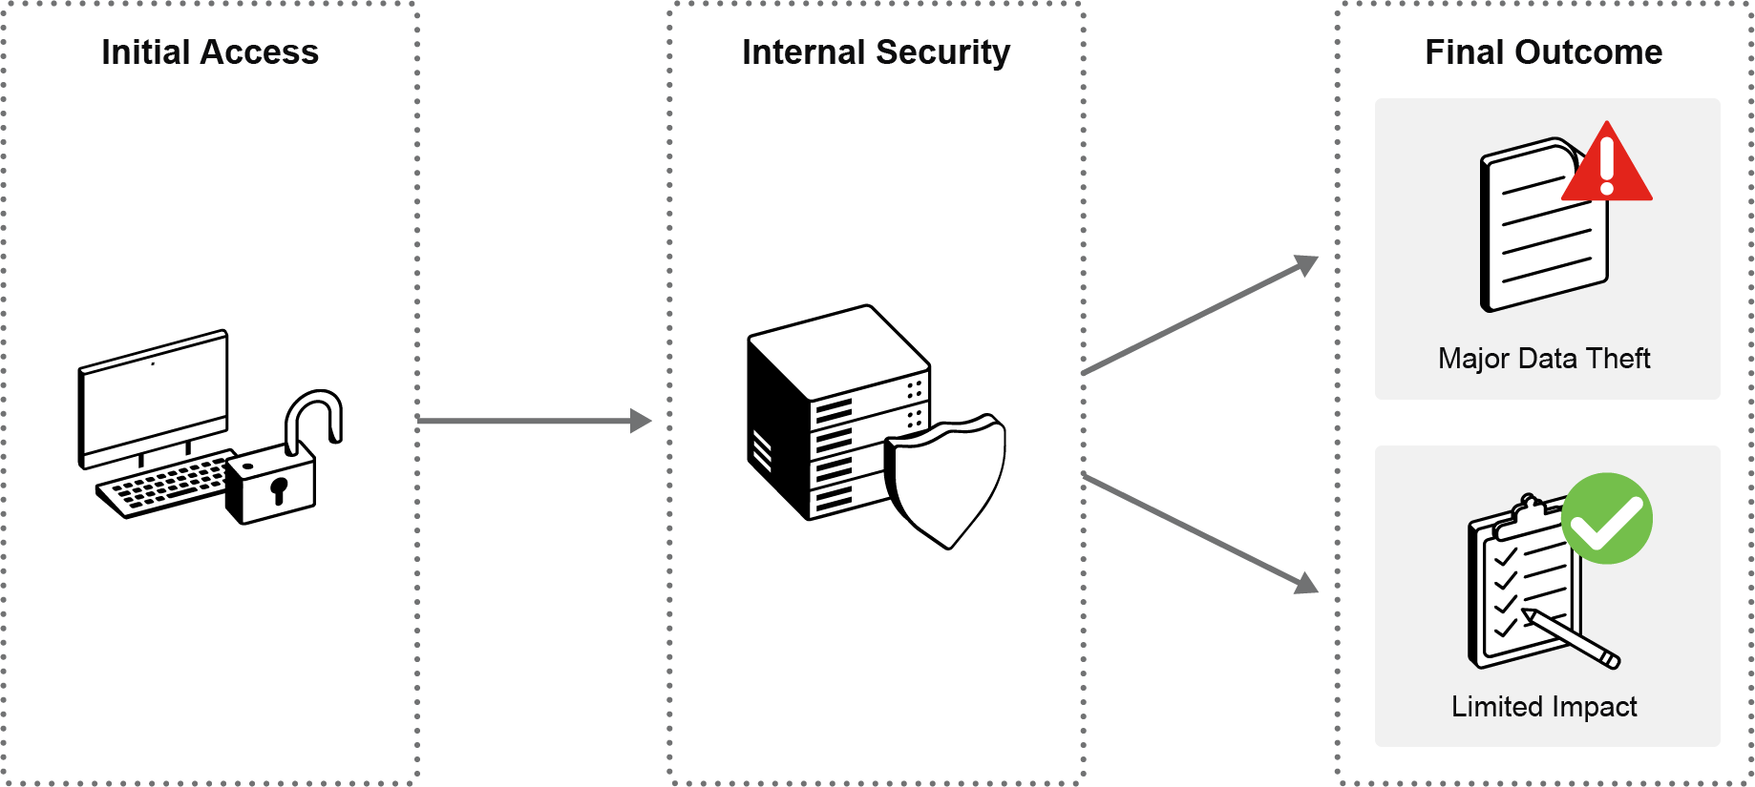
A data breach is not simply about data leaving the network. It is a loss of control over information that creates downstream obligations and business harm. Typical outcomes include:
- Disclosure of customer or employee data, such as personally identifiable information (PII), health information, such as protected health information (PHI), or payment card details, such as Payment Card Industry (PCI) cardholder data, which in turn triggers formal notification and reporting obligations.
- Intellectual property leakage (designs, source code, research, pricing models) that weakens competitive advantage and cannot be patched back.
- Credential and session leakage (tokens, API keys, cached passwords) that accelerates additional compromise, even if the original entry path is closed.

The impact of a data breach is no longer just an "IT problem"; it becomes a business crisis that can drive response costs, regulatory exposure, operational disruption, and reputational damage.
To exfiltrate data, attackers often slowly and methodically "trickle" it. The next focus is security intelligence, which plays a crucial role in defending against data breaches by providing actionable insights and real-time threat information that help organizations detect, prevent, and respond to attacks effectively.
1. A finance employee enters their details on a fake sign-in page. Within a day:
- The account successfully signs in to the enterprise resource planning (ERP) system from a new region.
- The same identity accesses a cloud HR portal and exports reports that it is normally allowed to view.
- A service integration that trusts the finance identity pulls billing data through an API.
- No malware appears. No systems are broken. The activity looks like valid usage.
Which statement best explains why the incident escalated from a single user's mistake into broad organizational exposure when a global company uses centralized identity and SSO across internal systems and multiple SaaS platforms?
A. The attacker used a vulnerability to bypass encryption and intercept traffic.
B. The attacker reused trusted identity and permissions across multiple systems.
C. The attacker secretly installed malware that generated fake user actions.
D. The attacker flooded systems with invalid login attempts until security tools failed.
2. Which of the following best describes the purpose of lateral movement by an attacker within a compromised network?
A. to discover and gain access to additional resources
B. to immediately exfiltrate data without further interaction
C. to disrupt normal operations
D. to establish a persistent presence

Cyber Security Intelligence Lifecycle
After the first signs of compromise, the team usually has only fragments of data to work with: access logs, suspicious domains, reused credentials, and traffic that deviates from normal patterns. A single observation rarely answers the key question: Is this activity connected to other activities? Is it credible? What does it suggest about the attacker’s intent?

The cyber threat intelligence lifecycle provides a structured approach to transform raw, scattered data into a clear, evidence-based understanding of threats. It achieves this by concentrating data collection on relevant information, enriching it with contextual details, assessing the confidence in the data, linking related threat activities, and continuously updating conclusions as new information becomes available. This process ensures that threat intelligence is actionable and reliable for informed decision-making in cybersecurity defense.
Cyber Threat Intelligence and Its Purpose
Cyber threat intelligence is structured, contextual knowledge about adversary behavior and infrastructure, derived from analyzing internal telemetry together with external reporting. It focuses on enriching otherwise isolated events, like logins, endpoint alerts, network connections, or API activity, with context, correlation, and historical insight so defenders can judge intent and significance. Cyber threat intelligence exists because modern attackers operate persistently at low signal strength, and it reduces uncertainty by turning scattered signals into evidence-based, context-aware conclusions.
The following figure highlights three key ideas about how cyber threat intelligence changes the way you interpret security data.
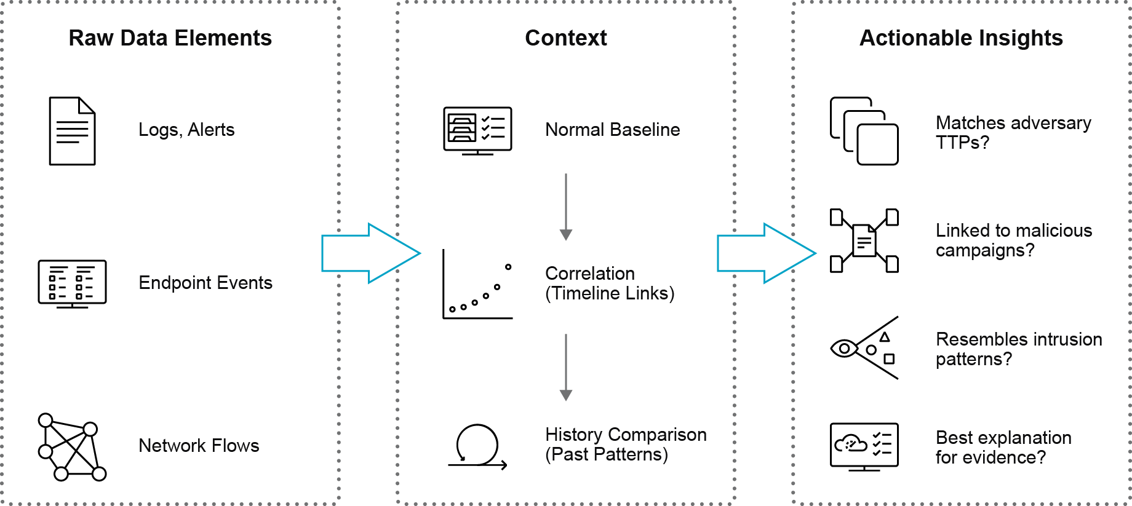
- Raw telemetry alone (logs, endpoints, network, cloud, apps) is high volume but low context.
- Cyber threat intelligence engines enrich, correlate, and compare events to past activity and known adversary tradecraft.
- The outcome is prioritized, explainable alerts that highlight likely threats and reduce uncertainty.

Threat Intelligence Types and Sources
Threat intelligence often gets mistaken for a single feed of indicators. A list of malicious domains or hashes may help validate one suspicious event, but it cannot explain why the activity occurs, what it resembles, or what it means over time. Intelligence operates at multiple levels of abstraction, so the same raw signals can support different decisions, from technical details to understanding the border campaign activities to guiding the organizational prioritization.
The following figure shows the core idea: the same underlying activity can be viewed at different altitudes, ranging from concrete observables to higher-level meaning. The event itself does not change, but the level of interpretation applied to it does.
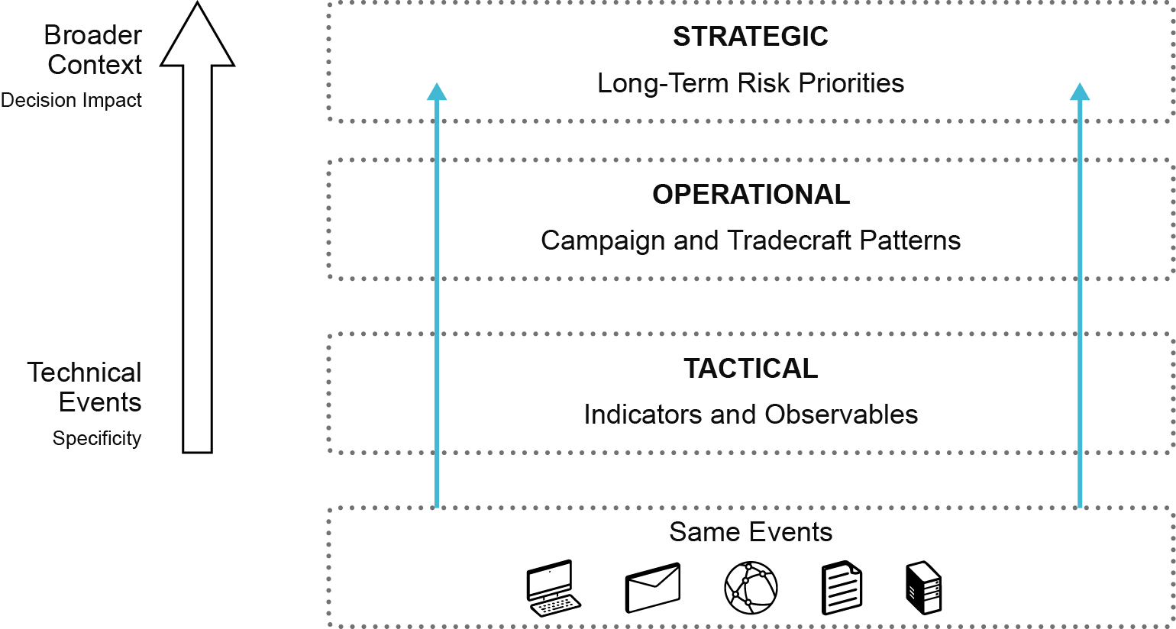
Examine how the same activity looks at tactical, operational, and strategic levels, with each level answering a different analytical question.
- Tactical
At the tactical level, intelligence focuses on specific observables such as IP addresses, domains, file hashes, or suspicious processes. These indicators of compromise (IOCs) are discrete artifacts linked to malicious behavior.
Tactical intelligence answers a focused question: Is this specific artifact malicious or suspicious?
- Operational
At the operational level, the view shifts from single indicators to patterns. A campaign represents a coordinated series of related malicious activities over time, often sharing infrastructure, tooling, targets, or delivery methods. Tradecraft patterns in security intelligence refer to the recognizable tactics, techniques, and procedures (TTPs) that attackers use to carry out their activities.
Operational intelligence answers a broader question: How is this adversary operating, and how do these events relate to one another?
- Strategic
At the strategic level, intelligence moves beyond events and patterns toward implications. Here, you focus on the adversary's capabilities, intent, targeting trends, and long-term risk exposure.
Strategic intelligence answers the question: What does this activity mean for the organization’s risk posture over time?

The key insight is that these intelligence types do not represent separate data sources. They represent layers of interpretation applied to the same underlying activity. Tactical intelligence identifies artifacts. Operational intelligence connects those artifacts into campaigns and tradecraft. Strategic intelligence evaluates what these patterns imply for risk, direction, and impact.
Use the following table to learn how intelligence changes as altitude increases in both analytical purpose and organizational impact. These layers are not separate feeds or products. They express different levels of interpretation on the same events, progressing from concrete observables to behavioral patterns to strategic meaning.
Intelligence Level | What You Analyze | Activity Coverage | Analysis Timeframe | How It Supports Operations
Tactical (low-level / concrete) | Individual artifacts (IP addresses, domains, file hashes, processes) | Single event or observable | Immediate/short-term | Validates and filters suspicious activity
Operational (mid-level / behavioral) | Campaign patterns, tradecraft sequences, infrastructure reuse | Related events across systems or over time | Ongoing activity | Reveals adversary methodology and persistence patterns
Strategic (high-level/contextual) | Adversary intent, capability, targeting trends, sector patterns | Industry or geopolitical context | Long-term | Informs risk posture, prioritization, and resource allocation

Intelligence also differs by origin and how you produce it. Internal sources come from within the environment: authentication events, endpoint telemetry, network flows, API activity, application logs, and artifacts recovered during investigations. External sources originate outside the organization, including public reporting, information-sharing communities, sector advisories, threat research teams, and partner disclosures.
From here, the focus shifts from classification to process: how you continuously collect, refine, validate, and update intelligence so it stays relevant as adversaries, infrastructure, and environments change.
Threat Intelligence Lifecycle
The Threat Intelligence Lifecycle is a structured process that transforms raw data into actionable intelligence to support informed decision-making in cybersecurity. It consists of the following five key phases:
- Planning and Direction
This initial phase involves defining intelligence requirements by starting with clear, relevant questions. It empowers analysts and teams to focus their efforts on what matters most to the organization.
- Data Collection
In this phase, data is gathered from various sources, including internal telemetry, external reports, and open-source intelligence. The goal is to collect relevant facts, observables, and measurements.
- Processing
Raw data is processed and structured, adding context and enrichment to transform it into meaningful information. This step involves summarizing and organizing data to prepare it for analysis.
- Analysis
Analysts examine the processed information to identify patterns, relationships, and implications. This phase converts information into intelligence by interpreting the data in context, assessing confidence levels, and linking related activities.
- Dissemination
The final phase involves delivering the intelligence to the appropriate stakeholders in a format suitable for their needs. This can range from tactical, operational, to strategic intelligence, depending on the audience and purpose.

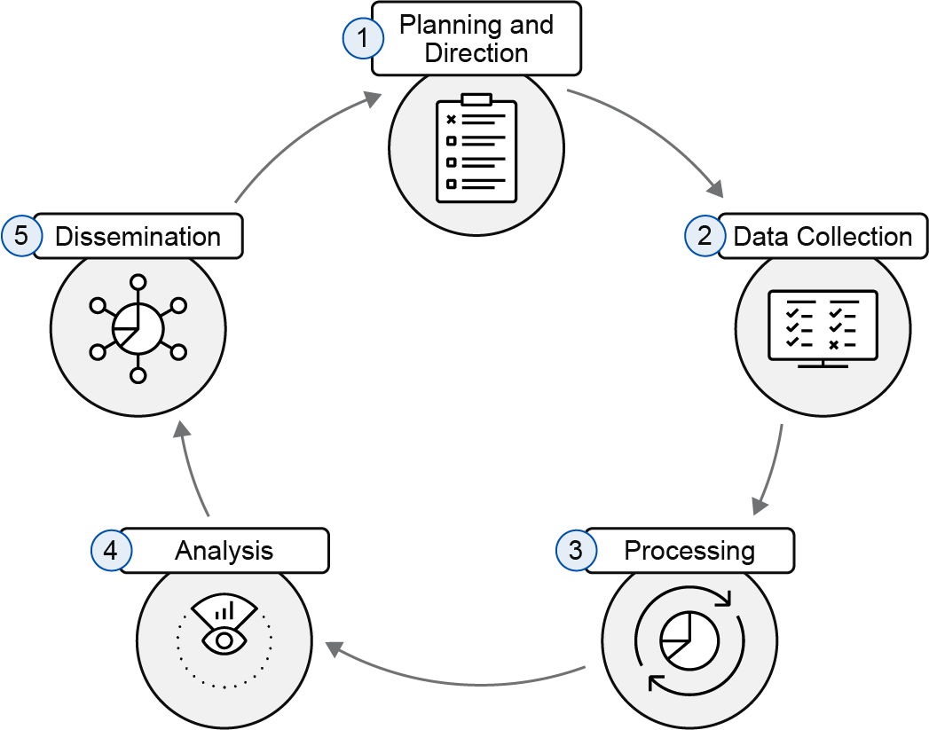
This lifecycle is continuous, with feedback loops allowing for refinement of intelligence requirements and ongoing updates as new data emerges. This ensures that cybersecurity teams move from scattered signals and raw data to evidence-based, contextual intelligence that supports better decision-making and risk reduction.
Threat Intelligence Sharing
STIX and TAXII enable organizations to subscribe to, share, and consume threat intelligence feeds in a standardized and automated manner.
- STIX (Structured Threat Information eXpression) is a standardized, structured, and machine-readable format used to describe cyber threat intelligence. It includes detailed information such as indicators, tactics, techniques, malware, and threat actors. STIX enables consistent representation of threat data, making it easier to share and analyze patterns of malicious activity.
- TAXII (Trusted Automated Exchange of Intelligence Information) is a protocol designed to securely and automatically exchange STIX-formatted threat intelligence data between systems, products, or organizations. TAXII defines services and message exchanges that facilitate the sharing of cyber threat information through dedicated TAXII servers.

1. Which statement best explains why cyber threat intelligence is needed even when an organization already collects extensive logs and alerts?
A. Logs often capture technical data points, but they cannot by themselves reveal intent or broader patterns behind activity.
B. Intelligence converts isolated, accurate events into contextual assessments about intent, relationships, and significance over time.
C. Intelligence tools can analyze available signals but still depend on experts to interpret them and confirm real threats.
D. Logs provide valuable operational details but lack the correlation and analysis to connect events effectively.

Summary
You now understand how modern cyber threats evolve in an environment where users, devices, and applications operate seamlessly across on-premises and cloud platforms. You can now recognize that, even in well-secured infrastructures where firewalls enforce access policies, software vulnerabilities are managed, and access controls are in place, the real challenge lies in the misuse of legitimate access rather than the exploitation of technical flaws.
You have examined how today’s attackers often operate within trusted boundaries, leveraging valid credentials, compromised identities, and authorized workflows. This understanding redefines what effective defense requires: identifying who these actors are, what motivates their actions, and which consistent techniques enable their success within legitimate systems.
You have also explored how detecting malicious intent demands more than monitoring isolated security events. An unusual login, an unexpected use of a service account, or a single phishing email may appear insignificant on its own, yet when correlated through actionable threat intelligence, these signals can reveal active compromise.
You now appreciate the role of cyber threat intelligence in connecting these indicators across organizational boundaries. By integrating intelligence feeds, sharing insights, and aligning contextual data, you can maintain continuous awareness of emerging threats and attacker techniques that evolve faster than traditional controls.
Finally, you should be able to address the following questions:
- What distinguishes different categories of threat actors, and how do their motivations and constraints influence their behavior and impact?
- How do initial access techniques vary across endpoints, identities, networks, and cloud applications?
- How can privilege escalation, credential compromise, and lateral movement transform limited access into a full breach?
- How is cyber threat intelligence produced, shared, and applied to maintain awareness of evolving threats within and beyond your organization?

Summary Challenge
1. An internal security review identifies a user who downloaded a large volume of sensitive design documents over several weeks without triggering any obvious alerts. The access occurred during normal business hours from typical corporate network locations, and the account had legitimate permissions to those resources. Which threat actor category best aligns with this behavior pattern?
A. nation-state APT
B. cybercriminal
C. hacktivist
D. insider
2. A group quietly maintains access to a government agency’s internal systems for many months, collecting sensitive strategic information without disrupting services or drawing public attention. Which motivation most accurately describes this threat actor’s primary objective?
A. immediate financial gain through ransom
B. public attention and reputational damage
C. strategic advantage aligned with national interests
D. personal revenge against an employer
3. An organization detects that several endpoints are making HTTPS connections to an unfamiliar domain that sits outside the normal communication baseline. The domain category is unusual for this environment, and the activity appears shortly after users open unexpected attachments. No user logins or approvals were involved. Which primary entry family does this situation most likely reflect?
A. social engineering and credential-based attack vectors
B. malware-based attack vectors rely on the execution of content
C. network-based availability vectors
D. cloud misconfiguration-enabled entry vectors
4. Which description best characterizes a network-based availability attack, such as DoS or DDoS?
A. It covertly changes access validation logic within an interface to extend authority beyond intended levels.
B. It floods limited resources with excessive traffic, preventing legitimate requests from being processed reliably.
C. It deliberately alters stored data formulas to disrupt the accuracy or reliability of core business outputs.
D. It uses deceptive communication methods to obtain user credentials and enable unauthorized network activity.
5. Which technical change most clearly explains why stolen credentials accelerate progression from foothold to breach?
A. They raise the system’s configuration level in a way that reduces external oversight or verification points.
B. They allow the attacker to inherit the identity’s existing trust relationships across applications and services.
C. They suppress key monitoring mechanisms, reducing visibility into authentication and activity anomalies.
D. They force the attacker to repeat exploitation patterns without gaining broader or sustained system access.
6. Company ABC detects that an internal project coordinator’s account was used to sign in through a familiar document-sharing workflow. From that session, the attacker:
- Accesses internal documentation and shared drives using the same authenticated context.
- Identifies an automation account with broad read–write permissions.
- Obtains that higher-privilege context and begins changing configurations across multiple systems.
Which combination best describes the attacker’s progression?
A. Lateral movement followed by privilege abuse, expanding from one context to broad centralized control
B. Direct compromise that grants complete environment access in a single intrusion event.
C. External observation activity that gathers information without entering internal resources.
D. Single-stage malware activity that limits its effect to one isolated system target.
7. What is the primary purpose of the Process step in the threat intelligence lifecycle?
A. Determine relevant business impacts and align collected data with compliance expectations.
B. Raw data is processed and structured, adding context and enrichment to transform it into meaningful information.
C. Identify patterns, relationships, and implications.
D. Deliver the intelligence to the appropriate stakeholders in a format suitable for their needs. This can range from tactical, operational, to strategic intelligence, depending on the audience and purpose.

Answer Key
Threat Actor Taxonomy and Motivations
- C
- C

Common Attack Vectors
- C
- B

Credential Compromise Impact on Data Breach Risk
- B
- A

Cyber Security Intelligence Lifecycle
- B

Summary Challenge
- D
- C
- B
- B
- B
- A
- B

